JOB DESCRIPTION

Job Title:  Healthy Communities Active Ageing Officer | Location: Office base is Bisham Abbey, Marlow (although due to COVID, GBA team members are currently working from home) but this role will require travel across the county, mostly West Berkshire and Reading.
Line Manager: Healthy Communities Manager, Get Berkshire Active | Hours of work: 22.5 hours per week (flexible)  Type of contract: Permanent
Salary: £22,000-£27,000 pro rata (based upon 37 hours per week full-time) | Line Reports: Initially no direct line management responsibilities however the post holder will liaise with casual instructors and volunteers.
JOB PURPOSE
The Healthy Communities Active Ageing Officer will work in identified areas across Berkshire to co-ordinate elements of Get Berkshire Active’s programmes aimed at improving the physical activity levels and health outcomes of the ageing population. The role will involve co-ordination and delivery of the project plan related to specific health projects. Alongside the project management function the role will also be responsible for delivering some project activities either directly or through partner agencies. For example, leading a gentle, chair-based exercise class.

The role (approx. 60-80% of capacity) will be predominantly focussed on supporting vulnerable, older residents and disabled residents in West Berkshire and Reading, as part of our Ever Active programmes. There are specific outputs and outcomes associated with these programmes that GBA has been commissioned to deliver, planning will be essential and monitoring and evaluating are integral to the role. For these programmes, the post holder will be required to organise, coordinate and (on some occasions) deliver appropriate interventions, in consultation with communities. These programmes aim to improve health and increased levels of physical activity alongside improved social connections and mental well-being, ultimately striving to reduce social isolation and loneliness. These programmes target the ageing population and people with disabilities and long-term health conditions. Programmes delivered by GBA involve significant numbers of partners working together and the post-holder will be required to manage delivery partnerships to achieve results.

The post-holder will also support other projects or areas of work focused on using physical activity as a vehicle to improve physical, mental and social health.
DESIGNATION OF POST AND POSITION WITHIN TEAM STRUCTURE
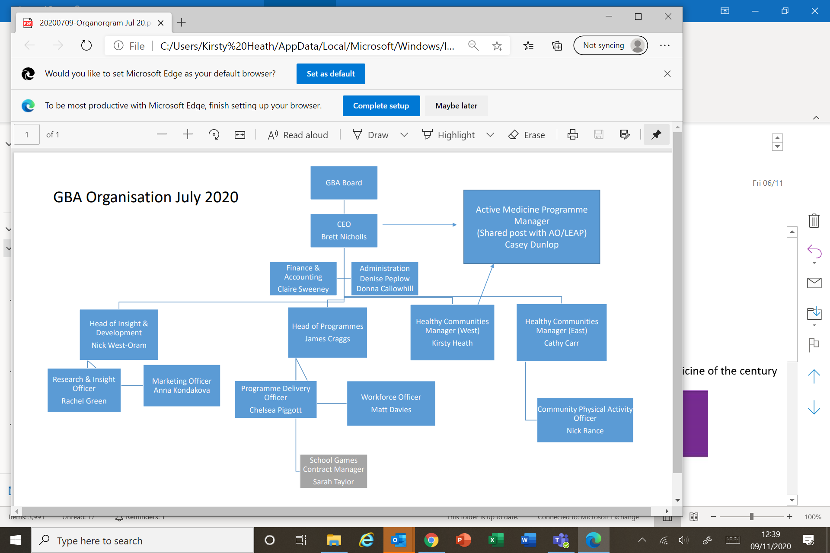
Active Ageing Officer
MAIN DUTIES AND RESPONSIBILITIES
- Co-ordinate delivery of Physical activity programmes for vulnerable and older adults (and disabled adults in West Berkshire) in West Berkshire and Reading. This includes community-based sessional activities and events. External deliverers can be sourced but the post holder will be expected to do some direct delivery themselves.
- Develop and deliver a buddy scheme to encourage participation in the Ever Active West Berkshire programme.
- Plan and implement (together with the GBA marketing officer) a marketing strategy specific to the Ever Active programmes.
- Co-ordinating and developing community volunteers and other measures to help ensure local delivery of programmes become sustainable.
- Implement all relevant programme protocols, processes and procedures including adherence to; monitoring and evaluating, equality and diversity, health and safety and safeguarding requirements.
- To represent the health interests of the community at meetings with partners and build links with other GBA programmes and those of our partners.
- Provide support in delivery and admin duties associated with other GBA programmes and/or work areas.
- Other reasonable duties as required to achieve the outcomes of the role.

The job description is an interpretation of the responsibilities of the post at the time of writing and does not form part of the contract of employment.
SCOPE OF JOB (Budgetary/Resource control, Impact)
Overall budget responsibility will remain with the Healthy Communities Manager however the Physical Activity Project Officer will be responsible for monitoring a budget associated with the deliverables involved in the Ever Active programmes.

PERSON SPECIFICATION
Qualifications / Education / Training:
 | CATEGORY | ESSENTIAL | DESIRABLE
1 | Five GCSE’s A* - C |  | X
2 | Otago Exercise Programme Leader or Postural Stability Instructor (or working towards) |  | X
3 | Level 3 Award in Exercise Programmes for Older Adults or similar (or working towards) | X

Experience:
 | CATEGORY | ESSENTIAL | DESIRABLE
1 | Experience of working with communities | X
2 | Management and delivery of successful projects | X
3 | Experience of delivering PA interventions for older adults | X
4 | Experience of instructing, teaching, coaching or mentoring |  | X
5 | Experience of user involvement in programme design |  | X
6 | Experience of working with the health, voluntary or public sector |  | X
7 | Experience of working with older adults and/or people with disabilities/long term health conditions. | X
8 | Knowledge and experience of working with key agencies responsible for delivering support for vulnerable, older adults and those managing health conditions |  | X

Knowledge, Skills and Abilities:
 | CATEGORY | ESSENTIAL | DESIRABLE
1 | Knowledge of factors contributing to good health, healthy lifestyles and means of initiating behaviour change within communities | X
2 | Detailed knowledge of the role of physical activity in preventing and treating long term health conditions. | X
3 | Health sector terminology, research, current thinking and best practice in relation to Physical Activity |  | X
4 | Knowledge of local need within Berkshire |  | X
5 | An understanding of working with older people, vulnerable adults or wider communities on health improvement initiatives | X
6 | Excellent inter-personal and communication skills. | X
7 | Open minded and empathetic as to health beliefs and needs of different communities. | X
8 | Ability to interpret and impart information effectively and in a way that engages and stimulates on all levels | X
9 | Excellent IT skills including email, word, excel and power-point | X
10 | Ability to produce written reports on work progress | X
11 | Monitoring programme budgets |  | X
12 | Excellent time management skills & ability to manage own workload. | X
13 | Strategic, critical thinking and decision-making skills |  | X
14 | Excellent Project Management skills and understanding of processes | X
15 | Ability to work with a wide range of partners and act with confidence | X
16 | Be able to work autonomously and to be self-motivated | X
17 | Ability to uphold confidentiality when appropriate and knowledge of when to escalate i.e. safeguarding | X
18 | Awareness of data protection protocols |  | X
19 | Committed to equal opportunities | X

Additional categories
 | CATEGORY | ESSENTIAL | DESIRABLE
1 | Genuine desire to contribute to the health and well-being of local communities. | X
2 | Willingness to be involved in professional development opportunities | X
3 | Access to a car and appropriate insurance to travel for work | X
4 | Willingness to act as coach / facilitator to deliver activities / sessions where necessary | X
Any offer of work in this post will be subject to a DBS check

