JOB DESCRIPTION

Job Title:  Activities Officer – Employability & Crime Prevention | Location: Various delivery locations across Berkshire. Office base and meetings will be at Bisham Abbey, Marlow.
Line Manager: Head of Sport England Programmes, Get Berkshire Active | Hours of work: Up to 37 hours per week (negotiable)  Type of contract: Permanent
Salary: £22,000-£28,000 pro rata (based upon 37 hours per week full-time) | Line Reports: Initially no direct line management responsibilities however the post holder will liaise with delivery contractors and ad-hoc independent coaches.
JOB PURPOSE
The Activities Officer – Employability & Crime Prevention will oversee deliver of Physical Activity to unemployed people and those at risk of offending. This unique role aims to prove that being more active and engaging in sport / physical activity can help provide positive outcomes for these groups. We use activities to help develop soft skills in those who are unemployed and self control, empathy and positivity in those at risk of offending. The objective is to encourage participants to become confident and motivated to undertake further training / education or to find work and therefore reduce their likelihood of becoming involved in crime.

The Activities Officer will work in identified areas across Berkshire to co-ordinate and deliver elements of Get Berkshire Active’s programmes aimed at improving social outcomes in targeted adult and youth populations. The role will involve co-ordination and delivery of the project plan related to a number of specific employability and crime preventions projects. The postholder will lead on the engagement, recruitment and sign up of participants to the programme. Relationship Management with referral agencies will be key, including partners such as DWP, Police, charities, youth offending, local authorities. Alongside this the postholder will directly deliver sessions (from time-to-time where appropriate) and liaise with partner agencies, personal development specialists, activity providers, clubs and coaches who will support a large part of delivery.

Initially the role will be focussed on supporting unemployed people but will develop a broader remit over time to work with those at risk of offending and potentially those suffering from - or at risk of developing -long term health conditions (including mental health) related to sedentary behaviour. The post holder will be required to deliver appropriate interventions in consultation with target audiences, to:
- Improve personal development - develop self efficacy, motivation and soft skills
- Influence offending behaviour /mindsets
- Improve health and physical activity levels
- Improve mental well-being

Whilst this work targets disadvantaged demographics, there is some specific focus on younger people and unemployed people.

We understand that this is a very unique post, combining elements of physical activity knowledge with employment and crime prevention experience. Therefore we are looking for individuals with experience in one of these areas, but who have the capability, interest and drive to challenge themselves to develop the skills and knowledge in other areas. If you have transferable skills and are a fast learner we will support you to grow and develop in the role with a wide range of CPD and personal development opportunities. This role may be appropriate for someone with:
- Recruitment / Work Coaching experience (with an interest in sport / physical activity)
- Youth / Offender Mentoring (with an interest in sport / physical activity)
- Sports coach / Physical Training Instructor (with knowledge / interest in employment / crime prevention)
- Health / Social Care / Housing Advisors
- Personal Development Coaches

The post holder will directly deliver and organise internal and external delivery of targeted personal development approaches based on evidence of need and best practice. The work programme for this post will be set by existing commissions and through the addition of future contracts within this space.

DESIGNATION OF POST AND POSITION WITHIN TEAM STRUCTURE
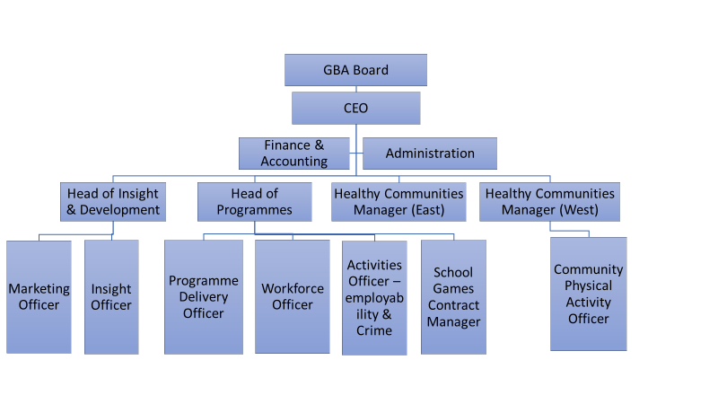

MAIN DUTIES AND RESPONSIBILITIES
- Oversee contracted output requirements and adherence to monitoring requirements
- The postholder will be required to deliver activity sessions/ events including the use of physical activity to develop soft skills such as communication, team work, problem solving, resilience, motivation, empathy, leadership etc
- Deliver activities that engage young people and adults to attend – including the recruitment of participants. Tailor activities to address risk taking behaviours that lead to offending
- Recommend and design new activities to address key personal development outcomes through ‘experiential learning’
- Co-ordinate delivery partners within the programme, partner communications, activities, collect and collate partner monitoring information
- Manage relationships with key referral partner frontline staff e.g DWP, charities, Local Authority, Police
- Implement all relevant programme protocols, processes and procedures including measuring impact and evaluation
- To deliver a calendar of programmes and taster sessions.
- Engage communities / groups
- To represent GBA at meetings with partners and build links with other GBA / partner programmes.
- Develop the role to further support health and social care outcomes
- Other reasonable duties as required to achieve the outcomes of the role

The job description is an interpretation of the responsibilities of the post at the time of writing and does not form part of the contract of employment.
SCOPE OF JOB (Budgetary/Resource control, Impact)
Overall budget responsibility will remain with the Head of Development and Insight however the Activities Officer will be responsible for monitoring a budget of between £40,000 and £150,000 for delivery of courses and interventions.

The postholder will be required to understand contract requirements and provide input to partner agencies to deliver outcomes.

PERSON SPECIFICATION
Qualifications / Education / Training:
 | CATEGORY | ESSENTIAL | DESIRABLE
1 | Five GCSE’s A* - C | X
2 | Health Promotion, Community Development Worker Qualification or Public Health Practitioner Level 5 or working towards or exercise rehabilitation for older adults or similar |  | X
3 | Level 3 Award in Exercise Programmes / REPs level 3 (or working towards) | X
4 | Motivational Interviewing, Experiential Learning, trauma informed practice or similar training |  | X

Experience:
 | CATEGORY | ESSENTIAL | DESIRABLE
1 | Experience of working with communities, unemployed people or offenders | X
2 | Experience delivering successful activity / coached sessions | X
3 | Experience of delivering Physical Activity interventions for disadvantaged groups or in developing soft skills |  | X
4 | Experience of leading and delivering employability or exercise / health promotion or crime prevention programmes / interventions | X
5 | Experience of tutoring, teaching, coaching or mentoring |  | X
6 | Experience of user involvement in programme design |  | X
7 | Experience of working with job centre plus, DWP, police, health, voluntary or public sector |  | X
8 | Experience of job searching, preparation and placement of candidates into work |  | X
9 | Experience of working with people with mental health issues, disabilities and vulnerable adults |  | X
10 | Knowledge and experience of behaviour change techniques |  | X
11 | Experience working with those at risk of offending / ex-offenders |  | X

Knowledge, Skills and Abilities:
 | CATEGORY | ESSENTIAL | DESIRABLE
1 | Detailed knowledge of the role of physical activity in preventing and treating long term health conditions especially mental health | X
2 | Knowledge of current thinking and best practice in relation to Physical Activity, health and coaching practice | X
3 | Knowledge of factors contributing to good health, healthy lifestyles and means of initiating behaviour change within targeted audiences |  | X
4 | Knowledge of the application of physical activity / experiential learning in personal development and soft skills |  | X
5 | Knowledge of Adverse Childhood Experiences, interventions / techniques to support youth offenders and ex-offenders |  | X
6 | Knowledge of local need within Berkshire |  | X
7 | Knowledge of lifestyle interventions at national or local level. Ability to horizon scan, identify and develop new opportunities with external funders in employability, crime prevention, health |  | X
8 | Excellent inter-personal and communication skills, especially the ability to persuade target participants to join a programme | X
9 | Excellent coaching, mentoring, training or youth work skills | X
10 | Ability to interpret and impart information effectively and in a way that engages and stimulates on all levels | X
11 | Excellent time management skills & ability to manage own work load. | X
12 | Ability to produce written reports on work progress | X
13 | Excellent Project Management skills and understanding of processes | X
14 | Skilled in dealing with difficult behaviour | X
15 | Skilled in candidate job placement and interview preparation |  | X
16 | Open minded and empathetic as to health beliefs and needs of different communities. |  | X
17 | Good IT skills including email, word, excel |  | X
18 | Monitoring programme budgets |  | X
19 | Critical thinking and decision making skills |  | X
20 | Ability to work with a wide range of partners and act with confidence |  | X
21 | Be able to work autonomously and to be self-motivated | X
22 | Ability to uphold confidentiality when appropriate and knowledge of when to escalate ie safeguarding | X
23 | Awareness of data protection protocols |  | X
24 | Committed to equal opportunities | X

Additional Requirements
 | CATEGORY | ESSENTIAL | DESIRABLE
1 | Genuine desire to contribute to the health and well-being of local communities. | X
2 | Willingness to be involved in professional development opportunities | X
3 | Flexibility to work evenings and weekends when required | X
4 | Access to a car and appropriate insurance to travel for work | X
5 | Willingness to act as coach / facilitator to deliver activities / sessions where necessary | X
Any offer of work in this post will be subject to an Enhanced DBS check

